# SCAN Outbound Patient Activity

**Job Name:** SCANPatientActivity under SQL Agent on SQLETL

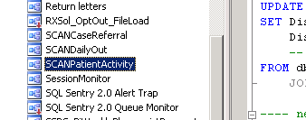

**Job Steps/Description:**

The SSIS package name is called ScanOutbound_Activity. Data is read out of the rdsmSCAN database and saved to the xActivityOutbound table. Any data that has not previously been sent is saved to an output file. This output file is then FTP’d to the PharmMD server via the datadump user (WinSCP). This communication outbound activity is then saved so it’s not retransmitted.

Output files are saved here (as of October 2017) \\sqlrdp\general$\ClientFiles\SCAN\Processed\_Daily\outbound\PatientActivity\

**Notes:**

This job should not allow duplicates as it logs patients sent to an Activity Log table (rdsmscan.dbo.activityoutboundlog) and checks this table before sending the next batch.

This job is run daily – 7 days a week.

**In Case of Failure:**

The file needs to be manually dropped onto the SCAN FTP site per Account Management. Credentials to this site may be known by the network team or Cynthia Sandahl. The FTP folder is called “Manual Drop Off”.